ACTIVITIES

EXERCICE 1:

Objective | Take all the apples.
Maximum number of instructions | 8
Allowed instructions | GO-UP GO-DOWN GO-LEFT GO-RIGHT PICK-UP REPEAT N-TIME WHILE IF
Allowed conditions | <HAS APPLE>
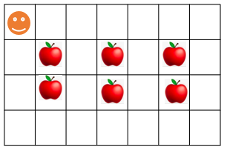

REPEAT<2>
Answer:
GO-DOWN

While-<Cell on the right>
GO-RIGHT

IF-<Has Apple>

Pick Up

While-<Cell on the left>

GO-LEFT

EXERCICE 2:

Objective | Bring all apples to their respective green box.
Maximum number of instructions | 10
Allowed instructions | GO-UP GO-DOWN GO-LEFT GO-RIGHT PICK-UP DROP REPEAT N-TIME WHILE IF
Allowed conditions | <HAS APPLE>

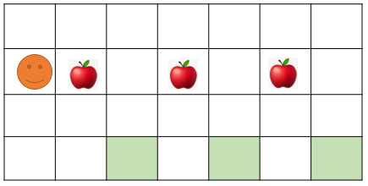

Answer:

EXERCICE 3:

Objective | Pick up all apple and stop at the flag!!
Maximum number of instructions | 6
Allowed instructions | GO-UP GO-DOWN GO-LEFT GO-RIGHT PICK-UP IF REPEAT N-TIME WHILE
Allowed conditions | <HAS APPLE> <HAS FLAG> <HAS NO FLAG>
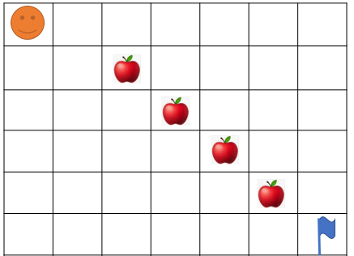

Answer:

EXERCICE 4:



What happen at the end?
- How many carrots Jack eats ?
- How many bananas Jack eats?
- Where will be Jack at the end?



EXERCICE 5:

Objective | Bring all apple to green box and stop at the flag!!  WARNING : you program must work for the 2 cases !!!
Maximum number of instructions | 10
Allowed instructions | GO-UP GO-DOWN GO-LEFT GO-RIGHT PICK-UP DROP IF REPEAT N-TIME WHILE
Allowed conditions | <HAS APPLE> <HAS CELL DOWN>  <HAS FLAG> <HAS NO FLAG>

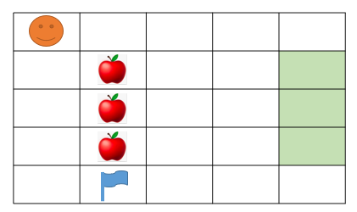
Case1:

=

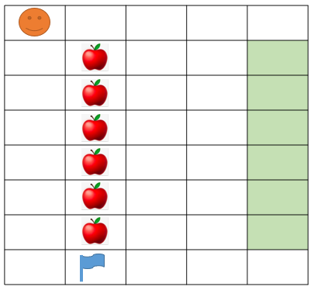
Case 2:

Answer:

EXERCICE 6:

Objective | Take all the apple to green box  WARNING: you program must work for the 2 cases!!!
Maximum number of instructions | 15
Allowed instructions | GO-UP GO-DOWN GO-LEFT GO-RIGHT PICK-UP DROP IF REPEAT N-TIME WHILE
Allowed conditions | <HAS APPLE> <HAS CELL ON RIGHT>  <HAS CELL ON LEFT>

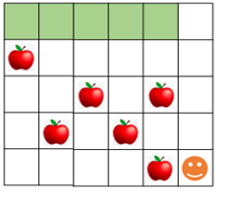
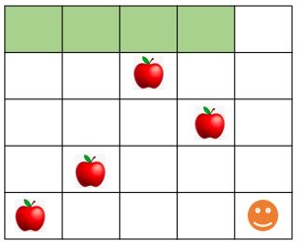

Answer:

EXERCICE 7:

Objective | Take all the apple
Maximum number of instructions | 8
Allowed instructions | GO-UP GO-DOWN GO-LEFT GO-RIGHT PICK-UP DROP  IF  REPEAT N-TIME WHILE
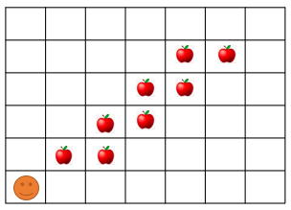

Answer:

EXERCICE 8:

Objective | Take all the apple and go to the green cell
Maximum number of instructions | 11
Allowed instructions | GO-UP GO-DOWN GO-RIGHT PICK-UP  IF  REPEAT N-TIME WHILE
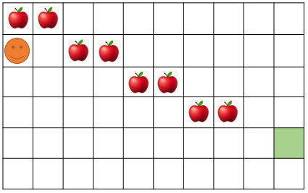

Answer:

EXERCICE 9:

Objective | Bring all apples put in the black cell and go to the green cell.  Note: your program must work for the 2 cases!!!
Maximum number of instructions | 10
Allowed instructions | GO-UP GO-DOWN DROP GO-RIGHT PICK-UP  IF  REPEAT N-TIME WHILE
Allowed conditions | <HAS APPLE> <HAS CELL ON RIGHT>  <HAS CELL ON LEFT> <HAS CELL ON UP>

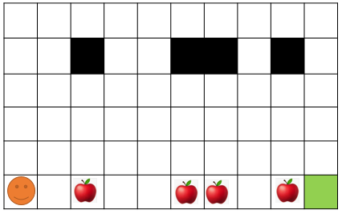
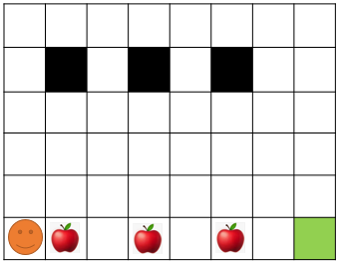

Answer:

